Report 1 - Analysis of turnover

This report you can find in Noom menu:
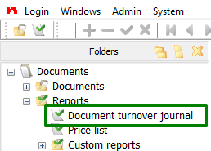

In the Document turnover journal view there is saved special reports for you. You can find the first report if you click on the Load icon:
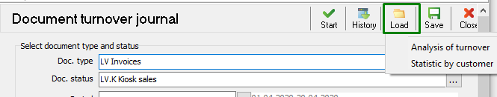
Choose the report name from the list and the report opens.
* in filters stands for „all“
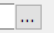 button opens filters list
1) Filter by date (daily, weekly, monthly, individual date-filter with Date & time)
In general this report is used by calendar days but if press on button and make right mouse click, then you can choose time period as well. To disable time period make again right mouse click on the button and change the values back as they were.
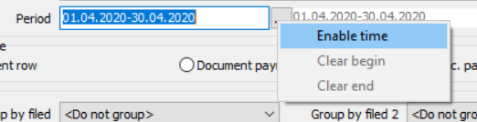
2) Filter by product (each one or all)
* stands for all. You can choose certain products from the list.
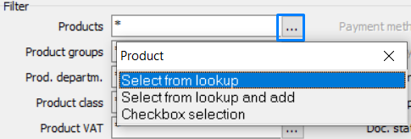
3) filter by customers (all customers, single customer with all cards, each card).
You can filter out by customers and cards.
4) Filter by location (individual or all)
With * you can take all locations. You can also filter by certain location.
You can see the report with all locations and group by location.
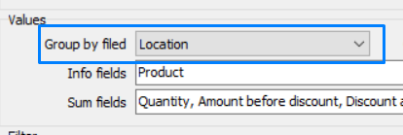

Example:
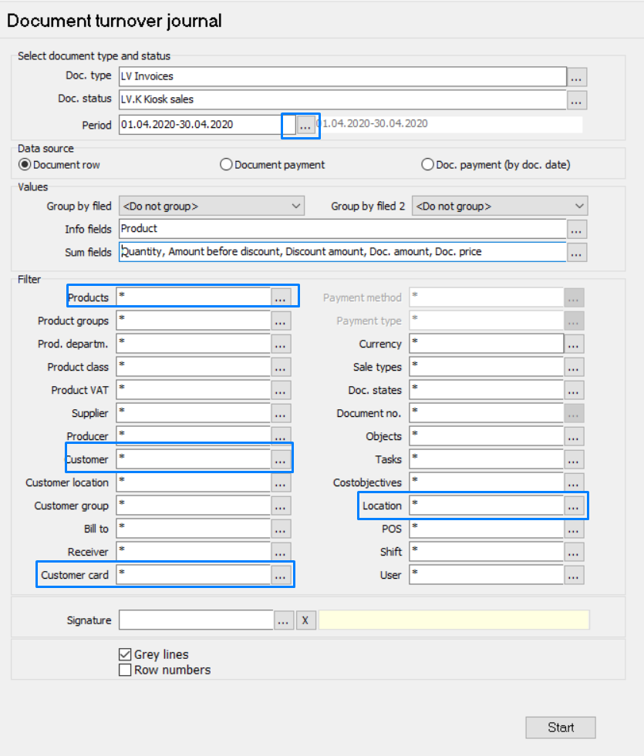
When you are ready with the changes, press on Start button.
The result should look like shown below:

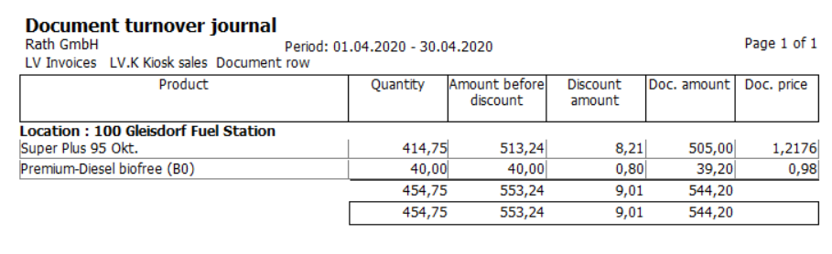

Report 2 - Statistic by customer

This report you can find in Noom menu in the same place where the Analysis of turnover locates:

You can find the report if you click on the Load icon:
Choose the report name from the list and the report opens.
Now when the report template is opened, please change data fields and apply customer filter:
Example:
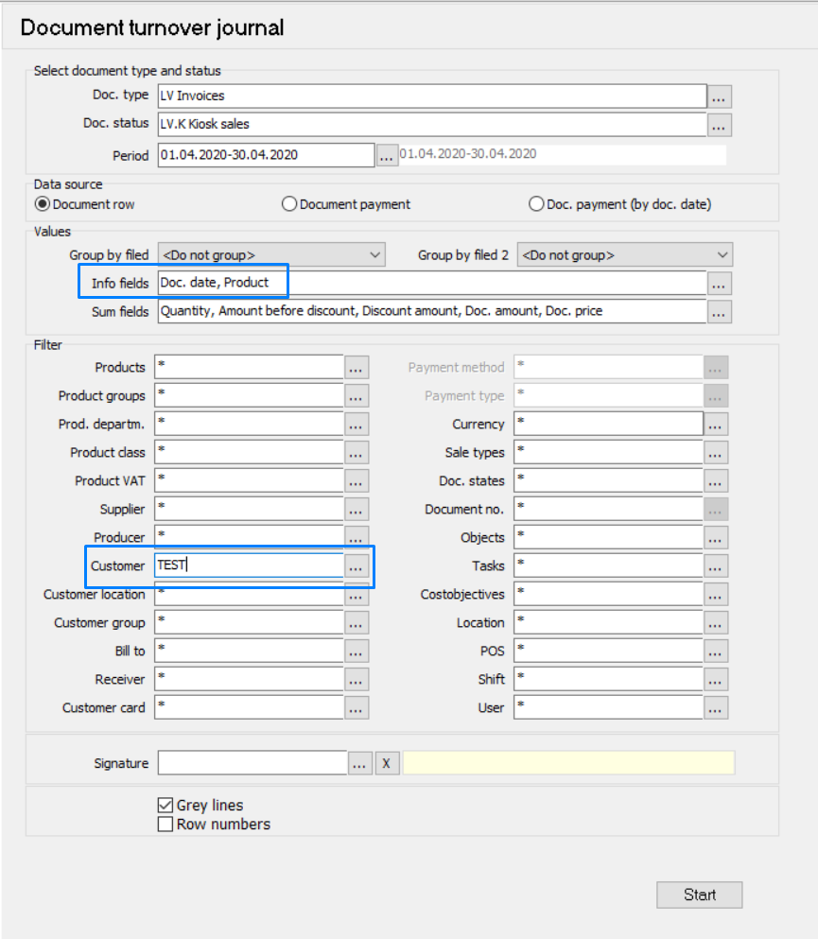
When you are ready with the changes, press on Start button.
The result should look like shown below:
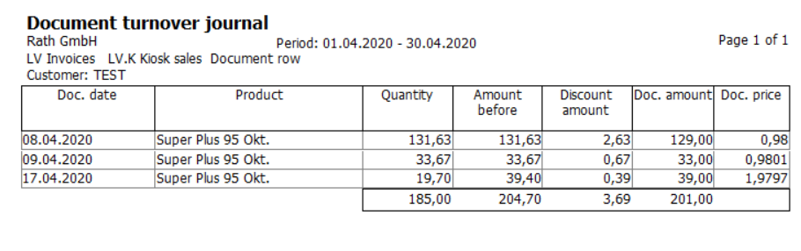
- Quantity - amount of liters
- Amount before - amount price €
- Discount amount - discount
- Doc. amount - invoice price €
- Doc. price - price per liter

Saving new report template
You can save the filters and selections you have made in Document turnover journal. To save the template and use it in the future, use Save button. You can then see the saved report template in the Load folder.
