Table of Contents
1.Product Price 1
1.1 Adding New Price 1
1.2 Changing Price 2
1. Discounts 3
2.1 Discount Groups 3
2.2 Adding Customer Group 4
3. Campaign 4
3.1 Adding New Campaign 4
3.2 Campaign Begin Date 7
3.3 Happy Hour Campaign 7
3.4 Base Price Changes during Happy Hour 8

1.Product Price

Adding New Price
Product price can be added in Noom as shown here:
- Product table is found under General data> Products.
- Click on the product you want to add price to. Before adding the price, make sure that Batch and Rec.Inf buttons are activated. Otherwise, the additional tables on the bottom right won’t be visible. Then press Edit button to enable change mode in Noom. Add price into Price field.
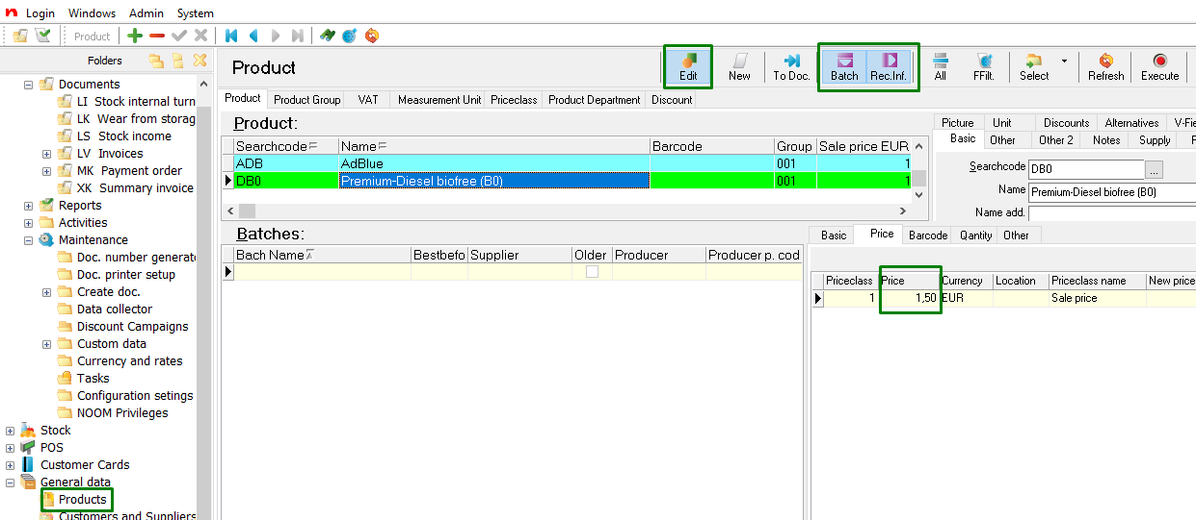
- Add location. If you have more than one location then you can add different prices for the locations. In order to add location-based prices to the product:
- Select the product from Product table.
- Go under Price tab and add new row by coping existing price row. Press F6 for coping the row. Keep the default row .*
- Add location for the new price row. Select location from the list. Click on the three dots icon, marked in the picture below. 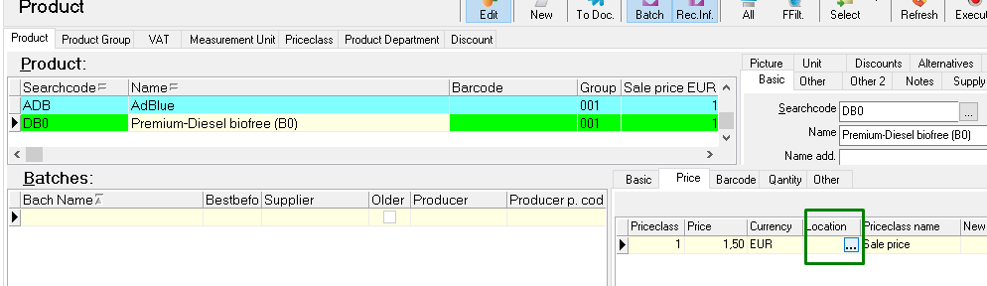
- Add suitable price for the location.
- Add as many other locations and prices for that certain product. F5 on your keyboard will create a new row.

* To have more than one price for a product in Noom there needs to be price without location.
Here is an example of a product which has different prices. One price is depending on the location and the other row that has no location applies to all other locations.
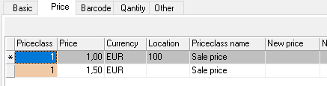

Noom always takes the location price from the field where there is that specific location marked. I.e. operating in location 100 will have 1,00 as a price whereas location 99 or 101 operate with 1,50 as a price.
There can be different variations on how to use prices on different locations. For example, you can have a product whose price is depending on the location or you can have a location where the prices are different than in other locations.

- Click on Save icon to save your changes.
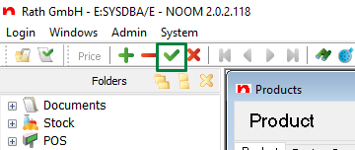

1.2 Changing Price
NB! Not to be mixed up with campaign solution!
Changing existing base price can be done in the same location in Noom as showed in the first chapter. First make sure that the Edit button is activated. If not, press the Edit button.
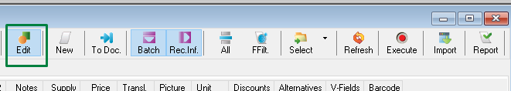
1. Add new price to the New price field. Also add the date when the new price is valid from to the New price valid from field.
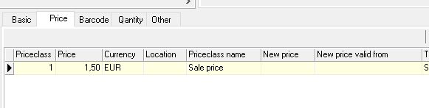
2. Save. Click on the Save icon when you are finished with the changes.

Discounts

2.1 Discount Groups

You can add discount to Customer Group or Customer Card. It defines what price the Customer will get. You can choose either method, both methods can’t be used.
For Rath Noom the discount has been defined by Customer Group. If needed you can always add and change the names and switch discount from Customer Group to Customer Cards.
Customer Group table can be found under General data> Customers and Suppliers.
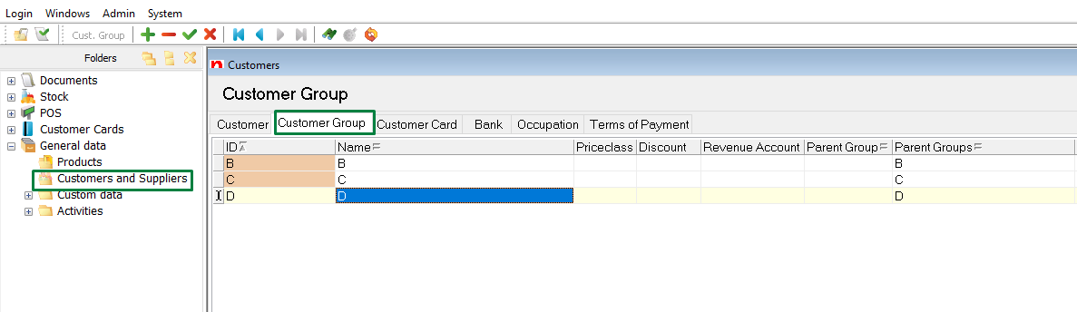

2.2 Adding Customer Group
Customers can be added into customer groups in Customers and Suppliers table. The customer can’t belong into more than one group at the same time.
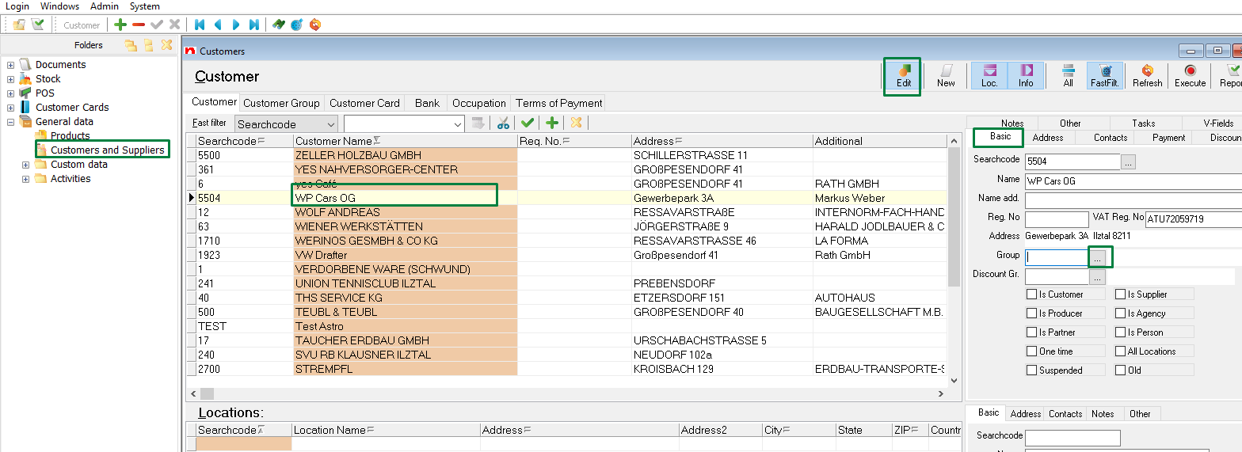
- Click on Group … button and choose the suitable value from list by making double click on the field.
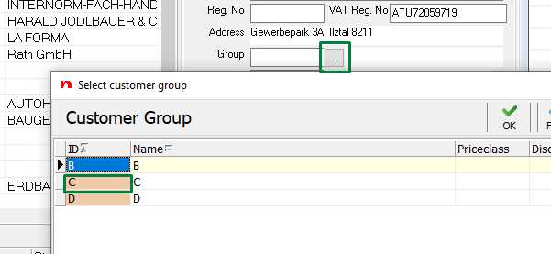
- Save. Click on the Save icon when you are finished with the changes.

Campaign

3.1 Adding New Campaign
New discount campaign can be added in Documents->Maintenance-> Discount Campaigns.
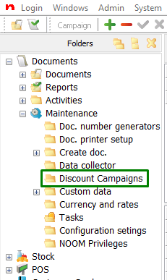
- Click on New button on the right corner.
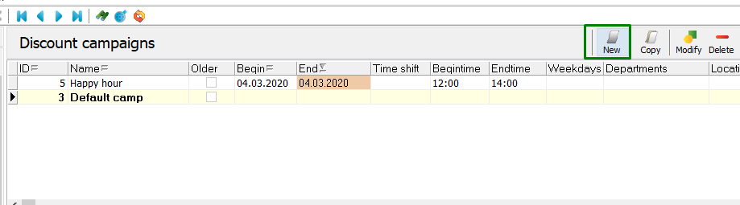
Noom opens a new window where you can add new campaign.
2. Add suitable Name. Filling fields in the green box is optional. The campaign can function without these specifications. 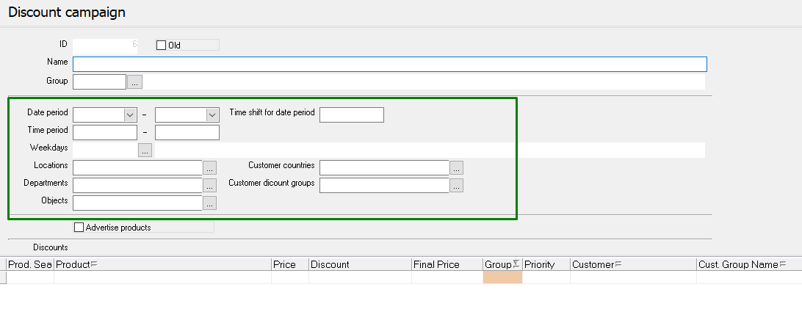
3. Add products by clicking the icon shown below. You can add new rows by pressing F5 button on your keyboard.
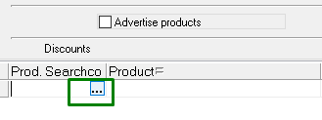
4. Add groups to the added products. Just write them directly into the Group field.
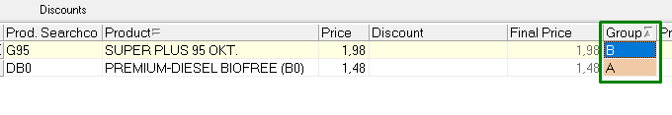
5. Add discount prices into Price field. This field indicates how many euros the customer gets discount from this certain product.
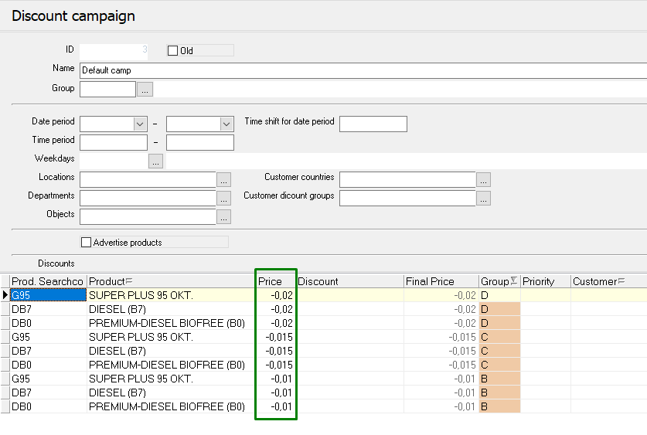
NB! Discounts are not summed up.
Noom takes the priority of the discount from priority nr (if it is implemented) or by the last added discount. The largest priority number will be the highest priority and the smallest number is the lowest priority. Using priority nr is optional not mandatory.
6. Adding priorities (optional)
Just add the suitable priority numbers directly into the Priority field:
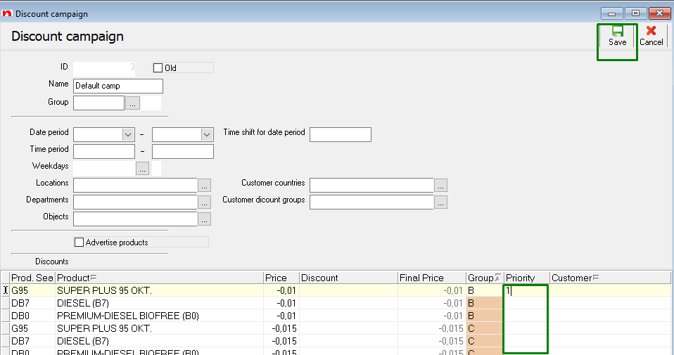
7. Save you changes, you have now finished adding a campaign!
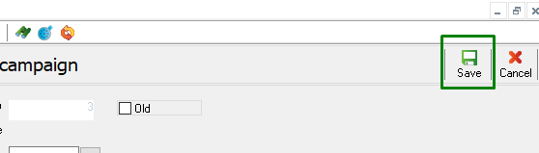

3.2 Campaign Begin Date

You can add campaign begin and end time if necessary. Those fields are not mandatory. If those fields are not filled, the campaign will always be in effect. In order to add begin time or prioritise existing campaigns just click on the Modify button and fill the desired fields.
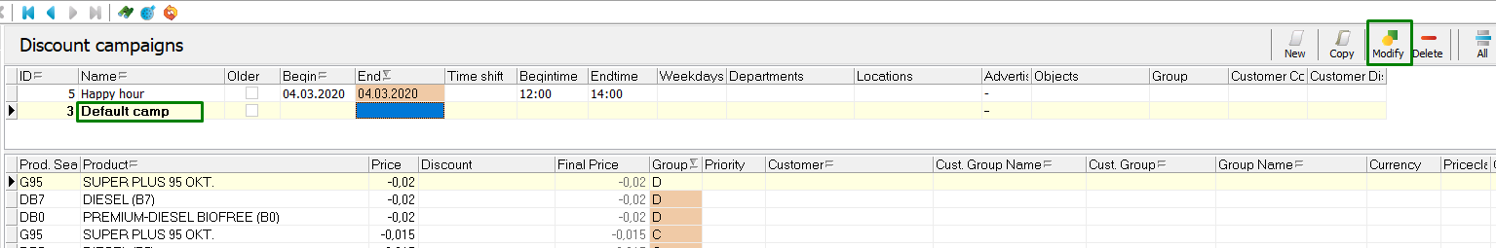

3.3 Happy Hour Campaign

Create happy hour campaign if you want to add a different discount or change the base price of a product. Add new campaign (as in chapter 3.1) or just copy the existing campaign (quickest way).
To copy an existing campaign, click on the campaign you want to copy and then click on the Copy icon (Ctrl +C works identically).
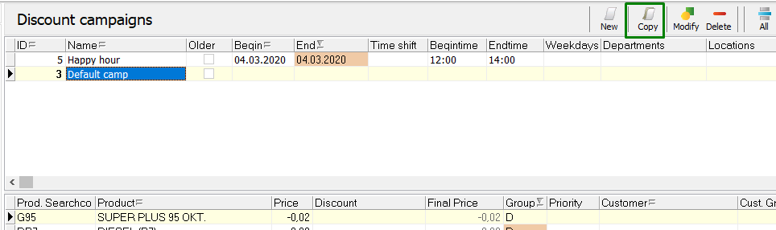

- In the opened window add name to the campaign.
- Define date and time period. The default campaing will automatically be valid (active) again once the marked period ends.
- Add or remove products (depending on if you copied the campaign or added a new one)
- Add Group (Group field)
- Add campaign price (Price field). For each group mark the price you want to apply for certain group on that period.
- Add priority.
Use priorities if you have more than one active campaigns and wish to prefer certain campaign to certain customers or customer groups.The larger the number the higher the priority.
For example if you want to apply a happy hour campaign to customer groups that already have a valid campaign then use priorities.
NB! Product base price (price marked on Product tabel) is always without group and is valid to everybody. Its the so called station price. Customers who do not belong into any customer group will get the station price (price marked on Product tabel)
Excample of happy hour: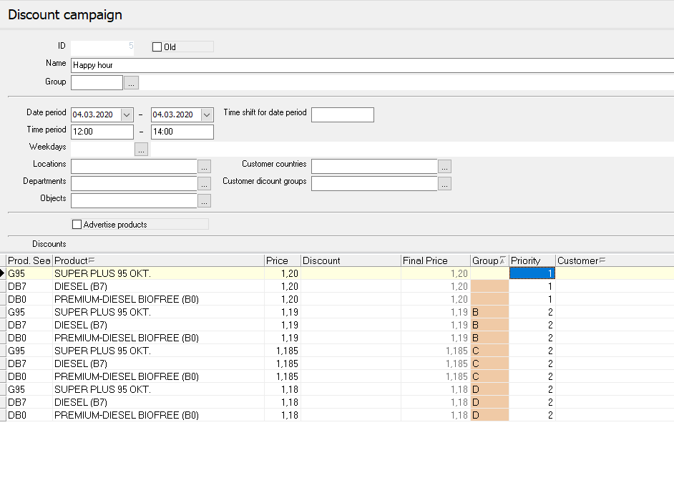

3.4 Base Price Changes during Happy Hour

There are cases where the product base price will be higher or lower than it was before the happy hour campaign. If you know that the base price will change and you want to apply a new base price just after the happy hour is over:
- Go under Product table (General data->Products).
- Select the product
- Add new price into New price field
- Add date and time into New price valid from. The date and time have to be the same as happy hour ending time. In our example 04.03.2020 14:00.
Example how to change base price after happy hour will end:
